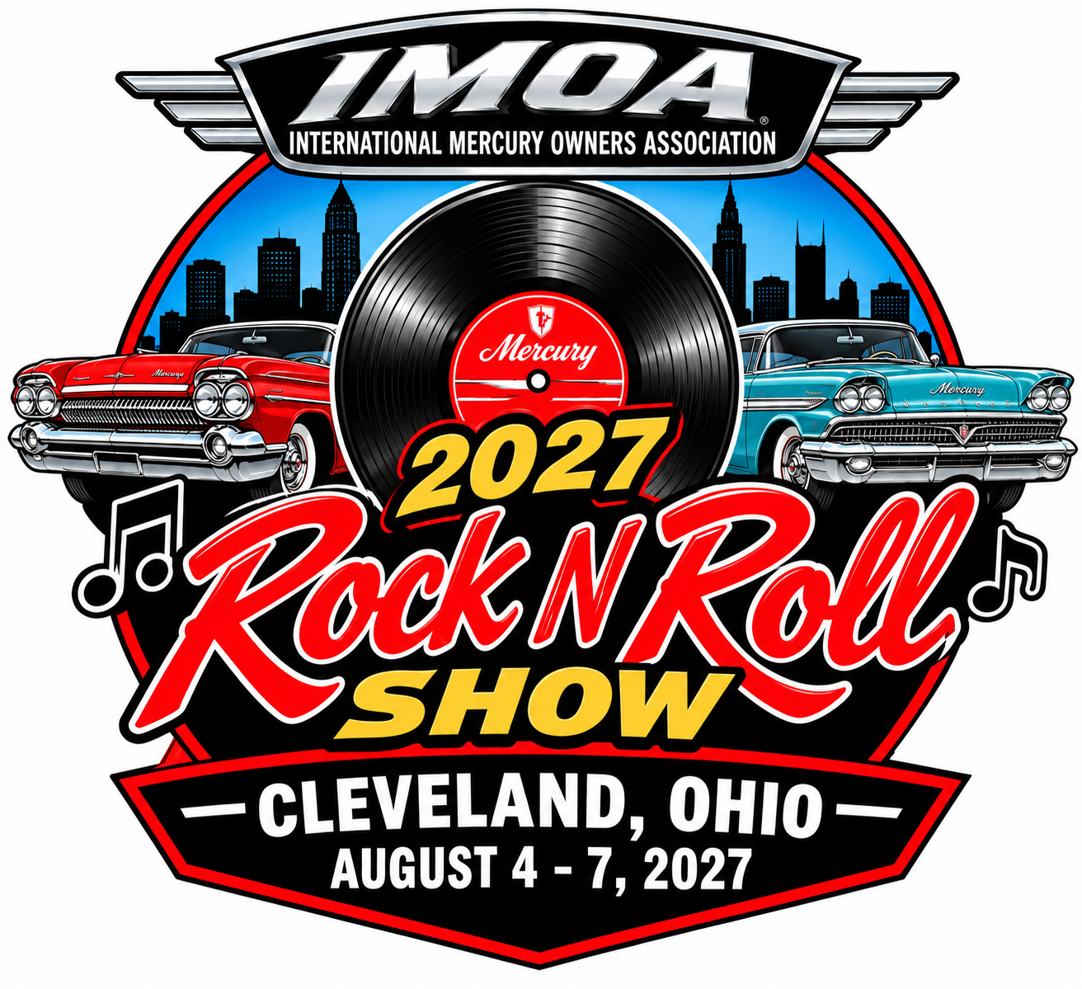
2027 “Rock N Roll” IMOA Show
Cleveland, Ohio • August 4–7, 2027
Optional: Wear clothing from the time period of your vehicle during the show. Best Costume Award(s) will be presented at the awards ceremony. All Mercury owners and enthusiasts are welcome, regardless of vehicle age. You do not have to be an IMOA member to register.
PARTICIPANT INFORMATION
Participant name(s) (participant + spouse): __________________________________________
Address: __________________________________________ City: __________________________
State: __________ ZIP: ______________ # of people attending: ______
Day phone: ________________________ Evening phone: ______________________________
Cell phone: _______________________ E-mail: ______________________________________

VEHICLE REGISTRATION
Vehicle 1 — Model: __________________________ Year: ______ Style: __________________
Judged? ☐ Yes ☐ No Modifications: ______________________________________________
Vehicle 2 — Model: __________________________ Year: ______ Style: __________________
Judged? ☐ Yes ☐ No Modifications: ______________________________________________

Model examples: Custom, Monterey, Montclair, Park Lane, Grand Marquis, Comet, Cougar, etc. Style examples: coupe, convertible, 2-door, 4-door, hardtop, sedan, station wagon, etc. Modifications are changes from the factory-stock version.
Important: Dash plaques are for pre-registered vehicles only. Vehicles cannot be entered for judging after July 5, 2027. All Mercury vehicles may be entered for judging; all cars are eligible for Participants’ Choice Awards.
REGISTRATION, T-SHIRTS & TOTALS
Show registration (includes one vehicle): $50 × ____ = $________
Additional vehicle(s): $50 each × ____ = $________
T-shirts: $20 each (M, L, XL) Qty: ____ Size(s): __________________ = $________
T-shirts: $25 each (2X, 3X, 4X) Qty: ____ Size(s): ________________ = $________
Crawford Air & Car Museum / WRHS: $13 per person Qty: ____ = $________
Rock & Roll Hall of Fame: $37.10 per ticket Qty: ____ = $________
GRAND TOTAL (registration + shirts + activities): $________________

T-shirts will be picked up at hotel registration or at the show.
HOTEL INFORMATION — RESERVE ONLY AFTER REGISTERING FOR THE SHOW
Best Western Strongsville • 15471 Royalton Road, Strongsville, OH 44136
Phone: (440) 238-8800, ext. 284 or 299 • IMOA rate: $129/night + taxes (single/double)
Room block cutoff: July 5, 2027 • Rate available 3 days before/after show, subject to availability.
When booking online or by phone, state that you are with the IMOA.
Trailer parking at hotel is minimal; trailer parking available in a roped-off area for cars.

TENTATIVE EVENT SCHEDULE
THURSDAY, AUGUST 5 — CRAWFORD AIR & CAR MUSEUM / WRHS
Hotel lobby registration: 8:00–9:30 AM • Depart hotel: 9:30 AM
Western Reserve Historical Society / Crawford Auto-Aviation Museum, 10825 East Blvd., Cleveland, OH 44106
Phone: (216) 721-5722 • $13 per person provides access to all WRHS museums.
Hotel lobby registration: 4:30–5:30 PM • Board meeting: time/location TBD
FRIDAY, AUGUST 6 — ROCK & ROLL HALL OF FAME
Hotel lobby registration: 8:00–9:30 AM • Depart hotel: 9:30 AM
Rock & Roll Hall of Fame, 1100 Rock and Roll Blvd., Cleveland, OH 44114 • Phone: (216) 781-7625
Ticket price listed: $37.10 per person • Hotel lobby registration: 4:30–5:30 PM
SATURDAY, AUGUST 7 — IMOA CAR SHOW
Show site opens 8:00 AM; registration at Crawford Museum from 8:00 AM
Show location: Crawford Auto-Aviation Museum front lawn and street directly in front of the museum
Judging begins 10:00 AM • Awards presentation 2:00 PM • Restrooms available
3:45 PM — Dinner with your IMOA family (pay as you go): Quaker Steak & Lube
5935 Canal Road, Valley View, OH 44125 • Phone: (216) 986-9464

PAYMENT
Payment method: ☐ American Express ☐ Discover ☐ MasterCard ☐ Visa
Card number: __________________________________________________________________
Security code: __________ Expiration (MM/YY): __________ Amount: $________________
Cardholder signature: ____________________________________________________________

RELEASE OF LIABILITY
I accept and assume full liability for any injury or loss to me or my property, agents, or employees at any time and from any cause on the premises of the show. I expressly release the International Mercury Owners Association and its agents or employees from any liability for such loss or injury and agree to provide and pay for my own insurance.
Signature: ________________________________________________ Date: __________________
MAIL-IN REGISTRATION
Return this form with your payment to: International Mercury Owners Association, P.O. Box 1245, Northbrook, IL 60065-1245
Website: www.mercuryclub.com
Questions: Kathy & Jerry Orcutt — 219-363-8366 (judging) • Show contact: Jerry Robbin — 847-997-8624
So long until next year!

